  
  

  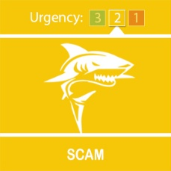
  Rogue Traders in & around Folkestone

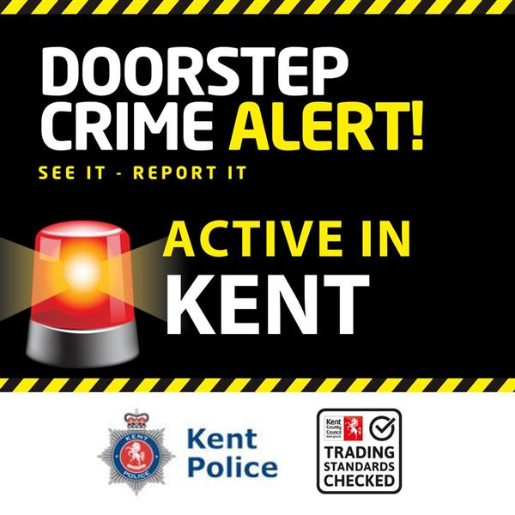
Rogue Traders have been active across the county but in particular in Folkstone.
Always get three quotes and use a safe, local trader that has been vetted by Kent Trading Standards - Trading Standards Checked
For further advice and infomation go to - Bogus tradesmen fraud | Action Fraud If you think that you may have been a victim of this or any other type of scam, then contact your Bank immediately, which you can do by calling 159 and report it to Action Fraud at www.actionfraud.police.uk or call 0300 123 2040.
For further information about Fraud, visit our website at Advice about fraud | Kent Police
You will also find valuable information from the Home Office at Stop! Think Fraud - How to stay safe from scams
 | Message Sent By  Emma Swietochowski-Hay  (Kent Police, Fraud Prevention Co-ordinator, Prevent and Protect)

